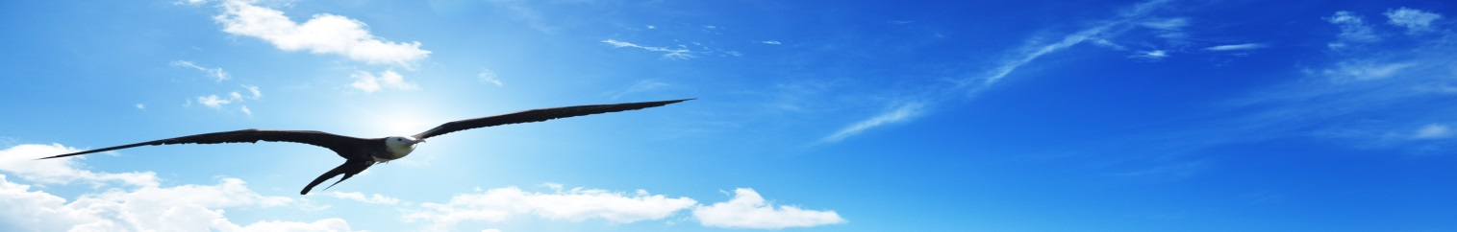
NATO DEFENSE COLLEGE FOUNDATION
STRATEGIC TRENDS
July 2015
MAGHREB
Tunisia’s delicate balance between security and democracy
Political developments in Maghreb in July 2015 were affected by security issues. The terrorist attack of the 26th June on a beach resort in Sousse had serious consequences in the following weeks, in particular for the economy of Tunisia: it is estimated that the negative effects of terrorism-related events on the tourism industry of the country (which makes up 7% of gross domestic product) could slow the GDP to 1% this year from 2.3% in 2014.
More in general, the attack represented the main terrorist event in the country after the 18th March storming of the Bardo museum in Tunis. In both cases the Islamic State claimed responsibility for the attacks, but it is not clear at the moment if the group had really directed and managed the operations.
The Tunisian government attributed the attack in Bardo to the al-Qaeda affiliated Okba Ibn Nafaa Brigade; and revealed the identity of the perpetrator of the Imperial Marhaba beach hotel attack in Sousse, which caused 39 victims, mainly British tourists. Saif Rezgui, a Tunisian student, was radicalized before fleeing to Sabratha, in Libya, where investigators believe he received military training in a jihadist camp, presumably operated by former Ansar al-Sharia members. Government officials admitted that they do not want to blame the Islamic State for the attacks in order not to advertise their involvement and contribute to their growth in popularity.
Nevertheless, government response to the attack was confused and criticized. Immediately after the attack, authorities closed more than 80 unregulated mosques believed to diffuse radical doctrines. Moreover, on the 13th of July the Minister of Interior, Najem Gharsalli, announced a recent operation by security forces that killed 5 terrorists of the Okba Ibn Nafaa Brigade, including its top leader Mourad Gharsalli. However, the Prime Minister Habib Essid acknowledged failures in the security system and the President Baji Caid Essebsi declared the state of emergency with a remarkable delay only on the 4th of July. In order to stop the militants’ flow to and from Libya, the government also announced the controversial building of a wall along the border, causing protests on both sides of the frontier by communities that rely on informal market economy to survive.
More in general, Tunisia’s delicate balance between security and democracy is under pressure. Apart from the increasing terrorist risks represented not only by instability in Libya, but also by the high number of Tunisian foreign fighters abroad (recent estimates by the United Nations increase that figure at 5.000), Tunisia’s recent adoption of contested measures is worrisome.
In June a court annulled the confiscation of former President Ben Ali’s assets, a decision the government vowed to appeal; furthermore, the 14th of July President Essebsi presented to the Council of Ministers a draft law on the ‘national reconciliation’ that has been criticized by the opposition as a masked amnesty for the former officials of both Ben Ali’s regime and the troika government (Ennhada, Ettakatol and Congrès pour la Tunisie). This apparent Tunisian inclination towards the past has been more evident during the visit of the former French President Nicolas Sarkozy in Tunis last 20th of July. After rebranding his political party Les Républicains and preparing his stance for 2017 French presidential election, Sarkozy paid tribute to the victims of the Bardo attack, but no one in the region forgot his support for Ben Ali regime and his role in the Libyan intervention.
Tribal clashes in south Maghreb
Instability in Maghreb created further occasion for communal infighting in different countries. In Algeria clashes occurred in Ghardaïa on the 8th of July causing 20 dead and injuring dozens. The fight between Arabs and the Mozabites minority (a Berber community professing Ibadism) is not new in the region and became increasingly worrying in 2013 with the destruction of the tomb of Amir Moussa (a Mozabite leader of the 16th century) and the Mozabite cemetery. These events led the Mozabites to accuse the government of marginalising the community, giving preferential treatment to Chaamba Arabs. The crisis in Ghardaïa obliged President Bouteflika to hold an emergency council with Prime Minister Abdelmalek Sellal and the army Chief of Staff Ahmed Gaid Salah. As a result, the Algerian government declared a partial curfew in the wilayah (province) and sent in military troops to restore the calm and to preserve the order.
Similar developments occurred on the other side of the frontier. The ongoing fighting in the city of Sebha between the Tebu and the Tuareg caused 4 victims on the 8th of July, confirming the constant and irregular fighting situation in the area of the last months. Nevertheless, violence escalated two weeks later when at least 40 people were killed in clashes in the same city. The Beida-based government asked the two communities to end their fighting and agree to a ceasefire, but it is unlikely that the two sides will listen to the appeals of such a fragile institution. Like in Algeria, the Tebu-Tuareg tensions are exacerbated by the country’s history: Tebu communities were particularly discriminated under the Gaddafi rule and contributed to the 2011 revolution that overthrew him, while the Tuareg largely backed the regime. For all these reasons, it is foreseeable that further clashes will occur in the next months, increasing sectarian tensions, unless the ongoing dialogue in Libya will provide with a solution to the country’s crisis and a new and effective government able to rein in tribal divisions.

